**Phase 2: Salesforce Org Setup & Configuration**

#### Project: AgriConnect -Smart Agriculture CRM

#### Institute: Prof. Ram Meghe Institute of Technology & Research

---------------------------------------------

**1. Salesforce Edition**

- Developer Org used for implementation

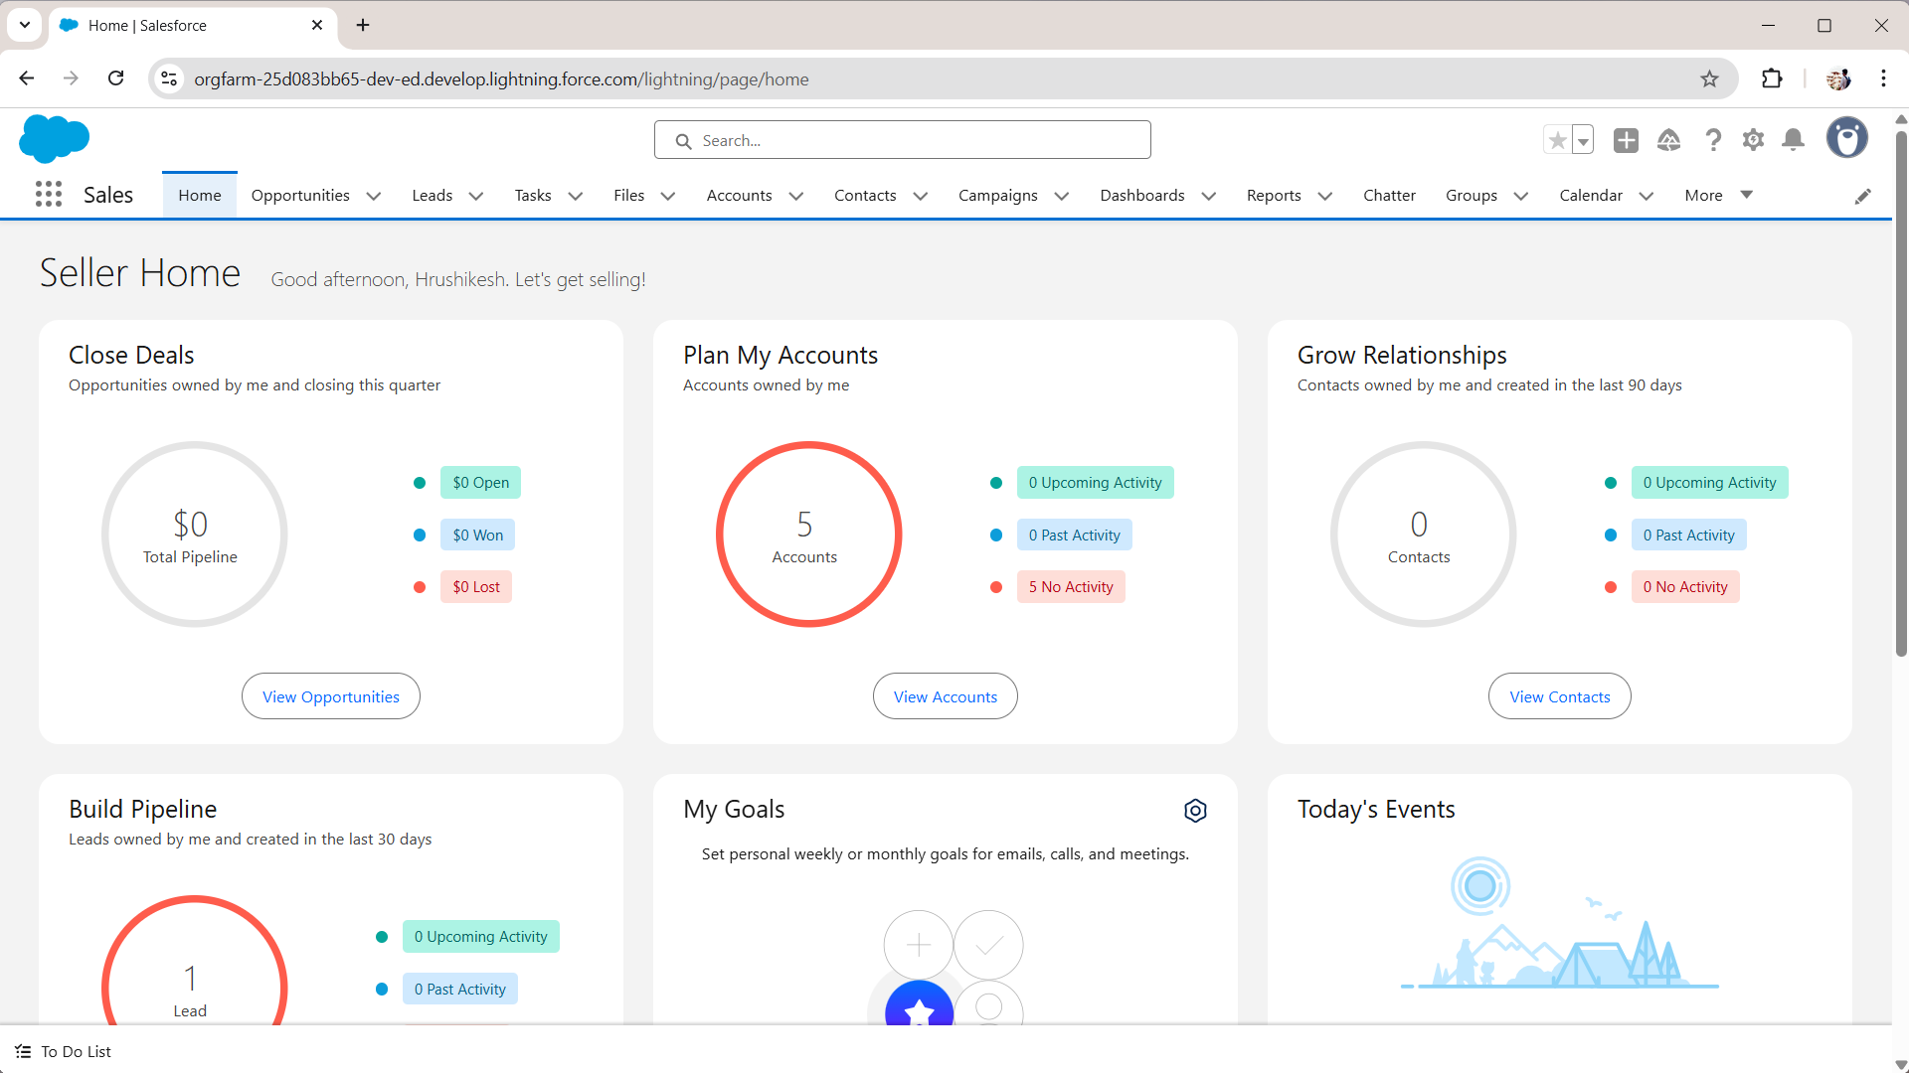

// I HAVE USED SAME ORG THAT WAS USED FOR TRAINING

**2. Company Profile Setup**

- Organization Name: Prof. Ram Meghe Institute of Technology & Research

- Default Locale: English (India)

- Default Currency: INR

- Default Time Zone: (GMT+05:30) India Standard Time

Process Flow: Setup → Company Information → Edit Company profile

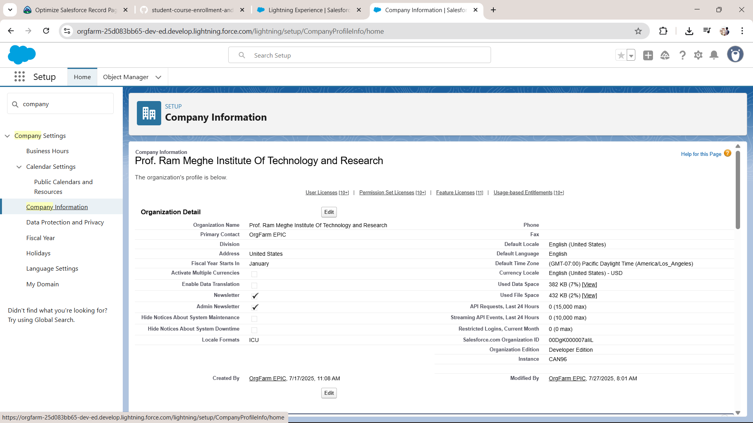

1. **Business Hours & Holidays**

- Business Hours: Default (All days, 05:00 AM – 12:00 AM)

Process Flow: Setup → Company Settings → Business Hours → Define & Assign

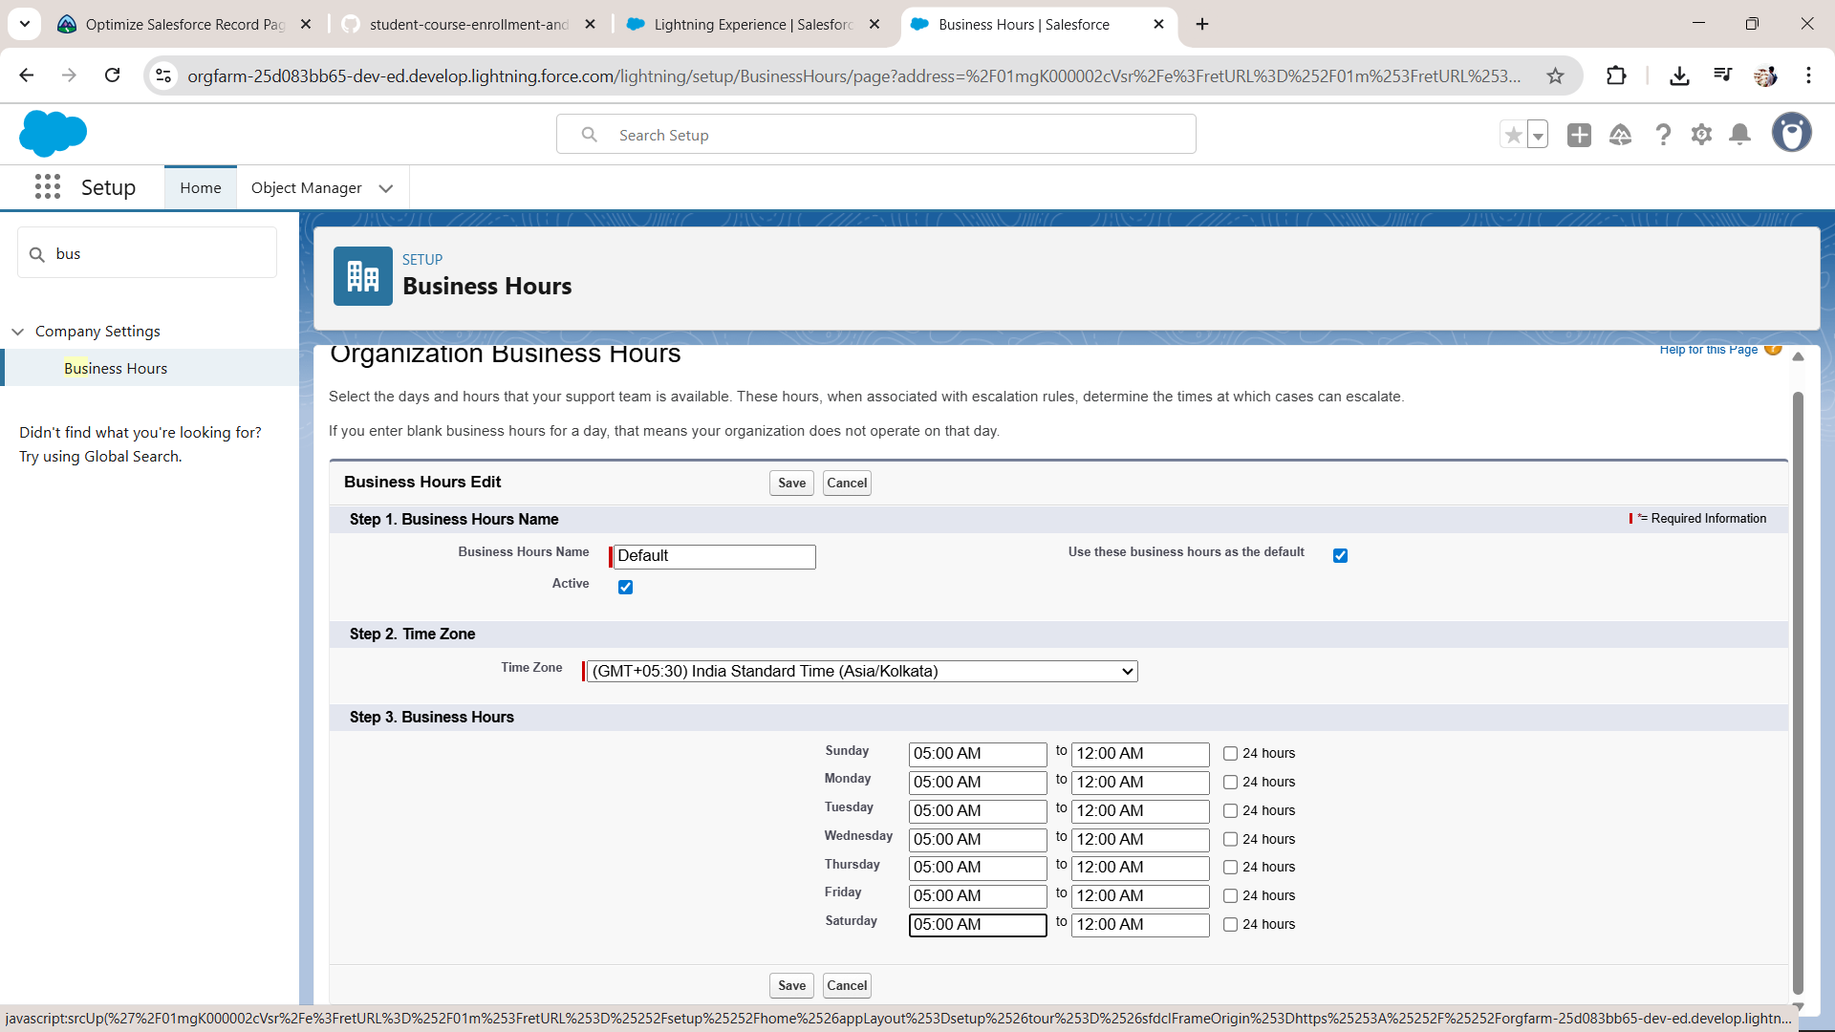

1. **Fiscal Year Settings**

Process Flow: Setup → Company Settings → Fiscal Year → Custom Fiscal Year (if required)

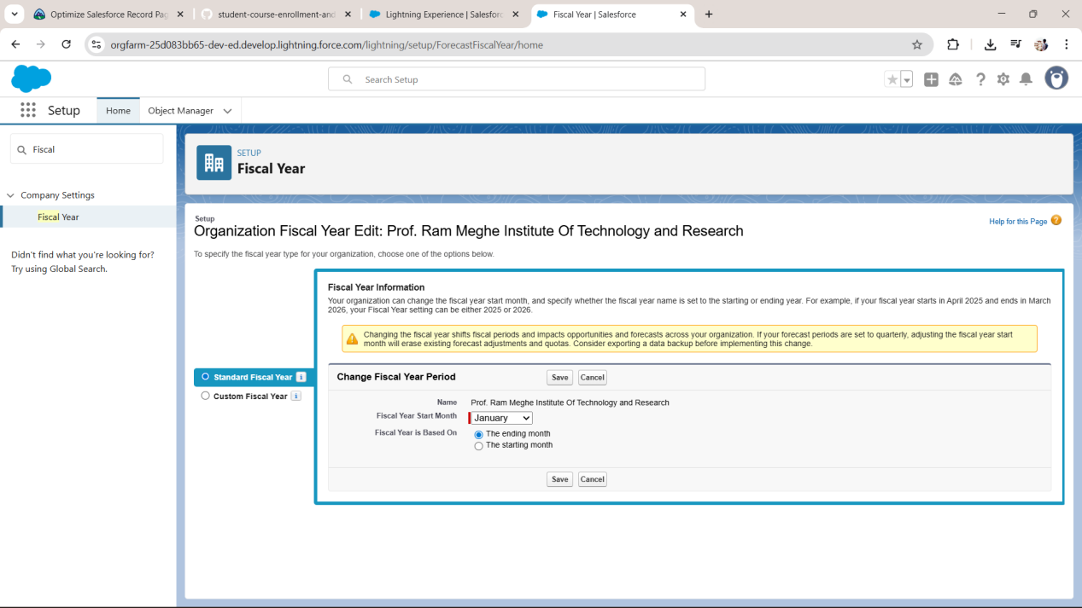

**5.User Setup & Licenses**

Ajay: License = Salesforce, Profile = System Administrator, Role = Assist

Process Flow: Setup → Users → New User → Assign License & Profile

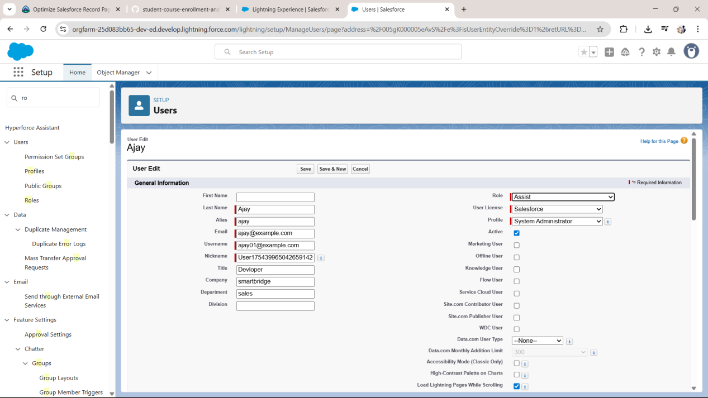

1. **App Creation**

* + Go to **App Manager** → Click **“New Lightning App”**→ Name the app “**AgriConnect**” →follow steps (ex : navigation items, next,.. save)

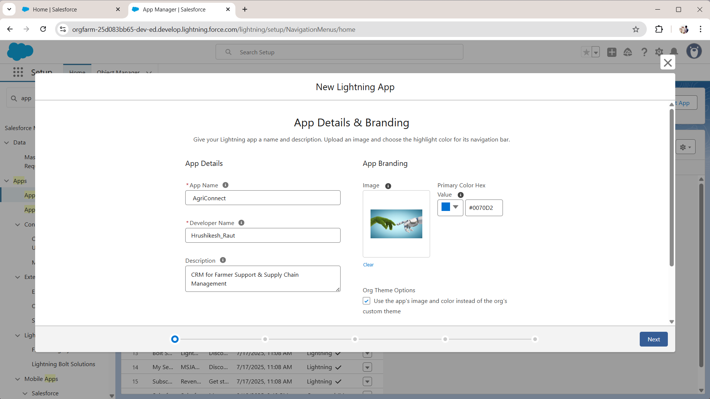

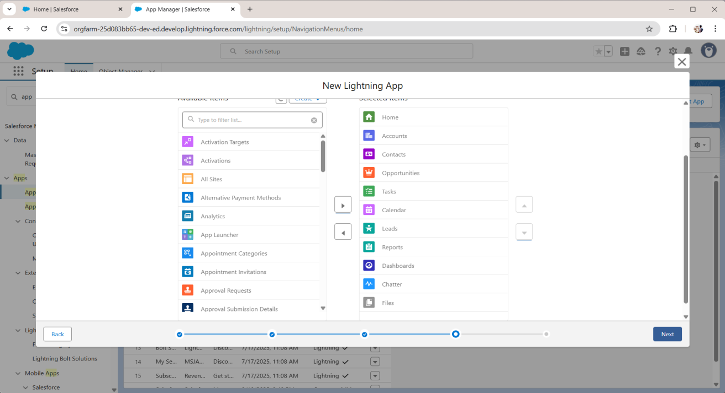

1. **Create Objects**

* + Go to **Object Manager** → Click **“Create”** → **Custom Object**
  + Define object name (Ex: “Farmer”, ”Buyer”, “Crop”,”Visit”,”Deal” )

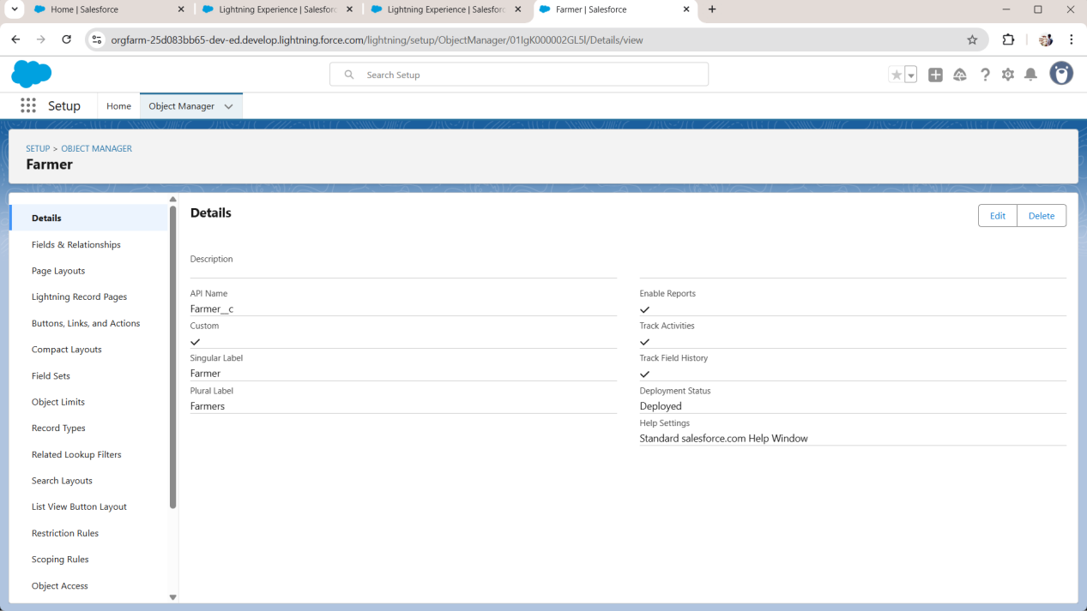

* + Add necessary fields (text, date, picklist, etc.)

1. **Create Custom feilds**

* + Inside the object, go to **Fields & Relationships**
  + Add new fields based on the project requirements
  + Fields & Relationship → New → Choose data type → next → label name →Fill reuirements →save

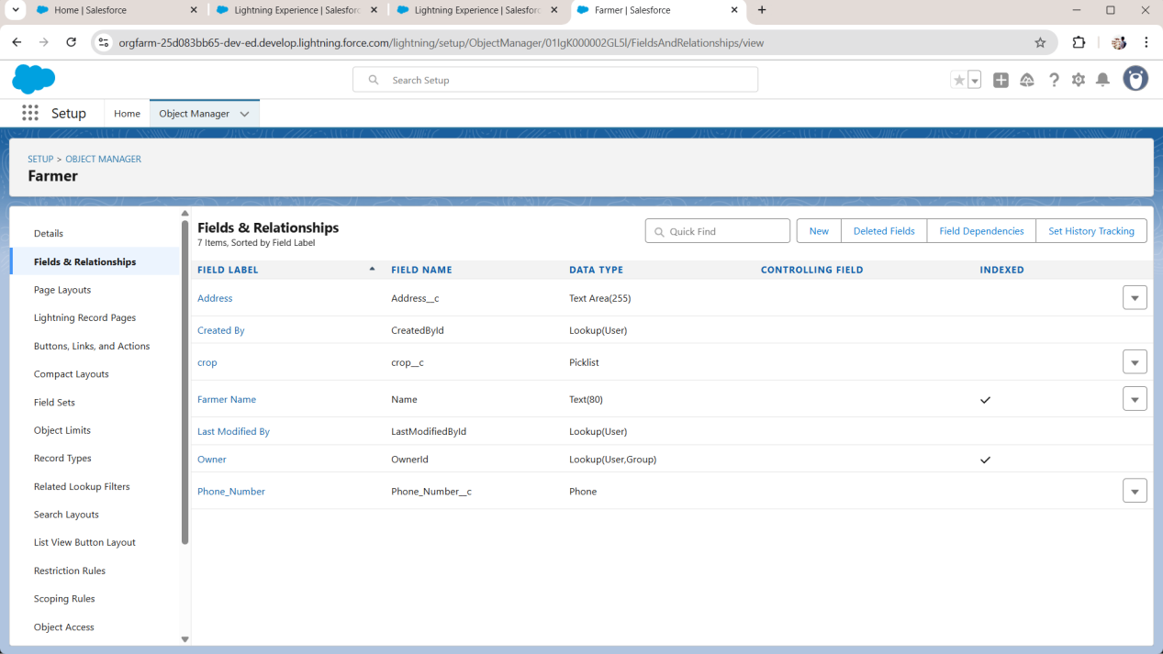

1. **Create Custom feilds**
   * Go to **Tabs** in Setup
   * Create a new tab for custom object

